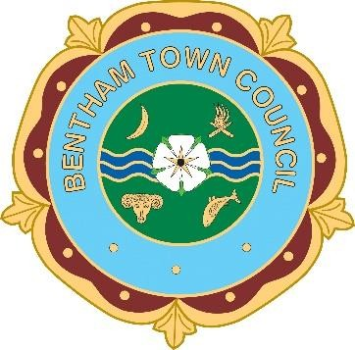
BENTHAM TOWN COUNCIL
Town Clerk: Bentham Town Hall,
Station Road, Bentham, Lancaster LA2 7LH
Tel/Fax: 015242 62587
Email: townclerk@benthamtowncouncil.co.uk

APPLICATION FORM – PRECEPT 2023
Name of Organisation
IS THIS ORGANISATION A  LIMIITED COMPANY? | YES |  | NO
Address of Organisation
Re Contact person: | Name
 | Address
 | Email address
 | Telephone No
 | Position in organisation
Re Project: Brief details / description of
project requiring funding (max 100 words
Anticipated total cost of project
Amount of grant required from the Council
The source of matched funding where applicable
Benefit to Bentham?
Organisations financial position for last complete financial year – please attach a copy of the latest accounts if
available.
Date of year end
Total income
Total expenditure
Funds available at
year end
DATE FORM COMPLETED
Return completed form to Town Clerk via email:townclerk@benthamtowncouncil.co.uk by 30th November 2023. Please note return date as late applications will not be considered.

